Mechanization Takes Command

Organizations as Machines

The Chinese sage Chuang-tzu, who lived in the fourth century B.C., relates the following story:

As Tzu-gung was traveling through the regions north of river Han, he saw an old man working in his vegetable garden. He had dug an irrigation ditch. The man would descend into the well, fetch up a vessel of water in his arms, and pour it out into the ditch. While his efforts were tremendous, the results appeared to be very meager.
Tzu-gung said, "There is a way whereby you can irrigate a hundred ditches in one day, and whereby you can do much with little effort. Would you not like to hear of it?" Then the gardener stood up, looked at him, and said, "And what would that be?"
Tzu-gung replied, "You take a wooden lever, weighted at the back and light in front. In this way you can bring up water so quickly that it just gushes out. This is called a draw-well."
Then anger rose up in the old man's face, and he said, "I have heard my teacher say that whoever uses machines does all his work like a machine. He who does his work like a machine grows a heart like a machine, and he who carries the heart of a machine in his breast loses his simplicity. He who has lost his simplicity becomes unsure in the strivings of his soul.
"Uncertainty in the strivings of the soul is something which does not agree with honest sense. It is not that I do not know of such things; I am ashamed to use them."

If the old man were to visit the modern world he would no doubt be very dismayed. For machines now influence virtually every aspect of our existence. While they have increased our productive abilities many thousandfold, they have also done much more, shaping almost every aspect of our lives. The debate initiated by Tzu-gung and the old man continues. In the view of many, mechanization has brought mainly gain, raising mankind from competitors with nature to virtual masters of nature. For others, the old man's vision of human alienation recurs in various forms, as they contemplate the high price of mechanical progress in terms of the transition from craft to factory production, the exchange of rural community for urban sprawl, the general degradation of the environment, and the assault of rationalism upon the human spirit.

Regardless of the stand one takes, the wisdom of the old mar's vision regarding the pervasive influence of machines remains beyond dispute. The use of machines has radically transformed the nature of productive activity and has left its mark on the imagination, thoughts, and feelings of humans throughout the ages. Scientists have produced mechanistic interpretations of the natural world, and philosophers and psychologists have articulated mechanistic theories of human mind and behavior. Increasingly, we have learned to use the machine as a metaphor for ourselves and our society, and to mold our world in accordance with mechanical principles.
This is nowhere more evident than in the modern organization.
Consider, for example, the mechanical precision with which many of our institutions are expected to operate. Organizational life is often routinized with the precision demanded of clockwork. People are frequently expected to arrive at work at a given time, perform a predetermined set of activities, rest at appointed hours, then resume their tasks until work is over. In many organizations one shift of workers replaces another in methodical fashion so that work can continue uninterrupted twenty-four hours a day, every day of the year. Often the work is very mechanical and repetitive. Anyone who has observed work in the mass-production factory, or in any of the large "office factories" processing paper forms such as insurance claims, tax returns, or bank checks, will have noticed the machinelike way in which such organizations operate. They are designed like machines, and their employees are in essence expected to behave as if they were parts of machines.
Fast-food restaurants and service organizations of many kinds operate in accordance with similar principles, with every action preplanned in a minute way, even in areas where personal interactions with others are concerned. Employees are frequently trained to interact with customers according to a detailed code of instructions, and are monitored in their performance. Even the most casual smile, greeting, comment, or suggestion by a sales assistant is often programmed by company policy and rehearsed to produce authentic results. The management observation checklist used by a famous fast-food restaurant to monitor employee performance (Exhibit 2.1) indicates the degree to which a simple task like serving a customer can be mechanized, observed, and evaluated in a mechanical way.

Greeting the customer | Yes | No
1. There is a smile.
2. It is a sincere greeting.
3. There is eye contact.
Other:
Taking the order | Yes | No
1. The counter person is thoroughly familiar with the menu ticket. (No hunting for items.)
2. The customer has to give the order only once.
3. Small orders (four items or less) are memorized rather than written down.
4. There is suggestive selling.
Other:
Assembling the order | Yes | No
1. The order is assembled in the proper sequence.
2. Grill slips are handed in first.
3. Drinks are poured in the proper sequence.
4. Proper amount of ice.
5. Cups slanted and finger used to activate.
6. Drinks are filled to the proper level.
7. Drinks are capped.
8. Clean cups.
9. Holding times are observed on coffee.
10. Cups are filled to the proper level on coffee.
Other:
Presenting the order | Yes | No
1. It is properly packaged.
2. The bag is double folded.
3. Plastic trays are used if eating inside.
4. A tray liner is used.
5. The food is handled in a proper manner.
Other:
Asking for & receiving payment | Yes | No
1. The amount of the order is stated clearly and loud enough to hear.
2. The denomination received is clearly stated.
3. The change is counted out loud.
4. Change is counted efficiently.
5. Large bills are laid on the till until the change is given.
Other:
Thanking the customer & asking for repeat business | Yes | No
1. There is always a thank you.
2. The thank you is sincere.
3. There is eye contact.
4. Return business was asked for.
Other:
Exhibit 2.l. A management observation checklist used to evaluate the performance of counter staff in a fast-food restaurant

Machines, mechanical thinking, and the rise of bureaucratic organization

Organizations that are designed and operated as if they were machines are now usually called bureaucracies. But most organizations are bureaucratized in some degree, for the mechanistic mode of thought has shaped our most basic conceptions of what organization is all about. For example, when we talk about organization we usually have in mind a state of orderly relations between clearly defined parts that have some determinate order. Although the image may not be explicit, we are talking about a set of mechanical relations. We talk about organizations as if they were machines, and as a consequence we tend to expect them to operate as machines: in a routinized, efficient, reliable, and predictable way.
In certain circumstances, which we will discuss in the concluding section of this chapter, a mechanical mode of organization can provide the basis for effective operation. But in others it can have many unfortunate consequences. It is thus important to understand how and when we are engaging in mechanistic thinking, and how so many popular theories and taken-for-granted ideas about organization support this thinking. For one of the major challenges facing many modern organizations is to replace this kind of thinking with fresh ideas and approaches, such as those to be discussed in subsequent chapters. Let us turn, therefore, to the story behind the development of our mechanistic concepts of organization.

THE ORIGINS OF MECHANISTIC ORGANIZATION

Organizations are rarely established as ends in themselves. They are instruments created to achieve other ends. This is reflected in the origins of the word organization, which derives from the Greek organon, meaning a tool or instrument. No wonder, therefore, that ideas about tasks, goals, aims, and objectives have become such fundamental organizational concepts. For tools and instruments are mechanical devices invented and developed to aid in performing some kind of goal-oriented activity.
This instrumentality is evident in the practices of the earliest formal organizations of which we know, such as those that built the great pyramids, empires, churches, and armies. However, it is with the invention and proliferation of machines, particularly along with the industrial revolution in Europe and North America, that concepts of organization really became mechanized. For the use of machines, especially in industry, required that organizations be adapted to the needs of machines.
If we examine the changes in organization accompanying the industrial revolution, we find an increasing trend towards the bureaucratization and routinization of life generally. Many self-employed family groups and skilled artisans gave up the autonomy of working in their homes and workshops to work on relatively unskilled jobs in factory settings. At the same time, factory owners and their engineers realized that the efficient operation of their new machines ultimately required major changes in the design and control of work. Division of labor at work, which was praised by the Scottish economist Adam Smith in his book The Wealth of Nations (1776), became intensified and increasingly specialized as manufacturers sought to increase efficiency by reducing the discretion of workers in favor of control by their machines and their supervisors. New procedures and techniques were also introduced to discipline workers to accept the new and rigorous routine of factory production.
Much was learned from the military, which since at least the time of Frederick the Great of Prussia had emerged as a prototype of mechanistic organization. Frederick, who ruled from 1740 to 1786, inherited an army composed for the most part of criminals, paupers, foreign mercenaries, and unwilling conscripts-an unruly mob. He was determined to change this, and quickly set about making reforms. He borrowed much from the practice of Roman legions and the reformed European armies of the sixteenth century, but also introduced numerous innovations of his own. Many of these were inspired by the mechanical inventions of his day.
In particular Frederick was fascinated by the workings of automated toys such as mechanical men, and in his quest to shape the army into a reliable and efficient instrument he introduced many reforms that actually served to reduce his soldiers to automata. Among these reforms were the introduction of ranks and uniforms, the extension and standardization of regulations, increased specialization of tasks, the use of standardized equipment, the creation of a command language, and systematic training which involved army drill. Frederick's aim was to shape the army into an efficient mechanism operating through means of standardized parts. Training procedures allowed these parts to be forged from almost any raw material, thus allowing the parts to be easily replaced when necessary, an essential characteristic for wartime operation. To ensure that his military machine operated on command, Frederick fostered the principle that the men must be taught to fear their officers more than the enemy. And to ensure that the military machine was used as wisely as possible, he developed the distinction between advisory and command functions, freeing specialist advisers (staff) from the line of command to plan activities. In time, further refinements were introduced, including the idea of decentralizing controls to create greater autonomy of parts in different combat situations.
Many of these ideas and practices had great relevance for solving problems created by the development of factory systems of production and were adopted in a piecemeal fashion throughout the nineteenth century, as entrepreneurs struggled to find organizational forms suited to machine technology. The new technology was thus accompanied and reinforced by mechanization of human thought and action. Organizations that used machines became more and more like machines. Frederick the Great's vision of a "mechanized" army gradually became a reality in factory and office settings as well.
During the nineteenth century a number of attempts were made to codify and promote the ideas that could lead to the efficient organization and management of work. Thus Adam Smith's praise of the division of labor was followed in 1801 by Eli Whitney's public demonstration of mass production, showing how guns could be assembled from piles of interchangeable parts. And in 1832 Charles Babbage, inventor of one of the earliest forms of the mathematical computer, published a treatise advocating a scientific approach to organization and management and emphasizing the importance of planning and an appropriate division of labor. However, it was not until the early twentieth century that these ideas and developments were synthesized in a comprehensive theory of organization and management.
One major contribution to this theory was made by the German sociologist Max Weber, who observed the parallels between the mechanization of industry and the proliferation of bureaucratic forms of organization. He noted that the bureaucratic form routinizes the process of administrations exactly as the machine routinizes production. In his work we find the first comprehensive definition of bureaucracy as a form of organization that emphasizes precision, speed, clarity, regularity, reliability, and efficiency achieved through the creation of a fixed division of tasks, hierarchical supervision, and detailed rules and regulations.
As a sociologist Weber was interested in the social consequences of the proliferation of bureaucracy and, rather like the old man in Chuang-tzu's story, was concerned about the effect it would have on the human side of society. He saw that the bureaucratic approach had the potential to routinize and mechanize almost every aspect of human life, eroding the human spirit and capacity for spontaneous action. And he also recognized that it could have grave political consequences in undermining the potential for more democratic forms of organization. His writings on bureaucracy are thus pervaded by a great skepticism, of which we will have more to say in Chapter 9.
The other major contribution was made by a group of management theorists and practitioners in North America and Europe who set the basis for what is now known as "classical management theory" and /"scientific management". In contrast with Weber, they were firm advocates of bureaucratization and devoted their energies to identifying detailed principles and methods through which this kind of organization could be achieved. While the classical management theorists focused on the design of the total organization, the scientific managers focused on the design and management of individual jobs. It is through the ideas of these theorists that so many mechanistic principles of organization have become entrenched in our everyday thinking. It is thus worth examining their work in some detail.

CLASSICAL MANAGEMENT THEORY: DESIGNING BUREAUCRATIC ORGANIZATIONS

Typical of the classical theorists were the Frenchman Henri Fayol, the American F. W. Mooney, and the Englishman Col. Lyndall Urwick. They were all interested in problems of practical management and sought to codify their experience of successful organization for others to follow. The basic thrust of their thinking is captured in the idea that management is a process of planning, organization, command, coordination, and control. Collectively they have set the basis for many modern management techniques, such as management by objectives (MBO); planning, programming, budgeting systems (PPBS); and other methods stressing rational planning and control. Each theorist codified his insights, drawing on a combination of military and engineering principles. Exhibit 2.2 summarizes some of the general principles of classical management theory.

Unity of command: an employee should receive orders from only one superior.
Scalar chain: the line of authority from superior to subordinate, which runs from top to bottom of the organization; this chain, which results from the unity-of-command principle, should be used as a channel for communication and decision making.
Span of control: the number of people reporting to one superior must not be so large that it creates problems of communication and coordination.
Staff and line: staff personnel can provide valuable advisory services, but must be careful not to violate line authority.
Initiative: to be encouraged at all levels of the organization.
Division of work: management should aim to achieve a degree of specialization designed to achieve the goal of the organization in an efficient manner.
Authority and responsibility: attention should be paid to the right to give orders and to exact obedience; an appropriate balance between authority and responsibility should be achieved. It is meaningless to make someone responsible for work if they are not given appropriate authority to execute that responsibility.
Centralization (of authority): always present in some degree, this must vary to optimize the use of faculties of personnel.
Discipline: obedience, application, energy, behavior, and outward marks of respect in accordance with agreed rules and customs.
Subordination of individual interest to general interest: through firmness, example, fair agreements, and constant supervision.
Equity: based on kindness and justice, to encourage personnel in their duties; and fair remuneration which encourages morale yet does not lead to overpayment.
Stability of tenure of personnel: to facilitate the development of abilities.
Esprit de corps: to facilitate harmony as a basis of strength.

These principles, many of which were first used by Frederick the Great and other military experts to develop armies into "military machines," provided the foundation of management theory in the first half of this century. And their use is very widespread today.
Exhibit 2.2. Principles of classical management theory

If we implement these principles, we arrive at the kind of organization represented in the familiar organization chart (Exhibit 2.3): a Pattern of precisely defined jobs organized in a hierarchical manner through precisely defined lines of command or communication. And if we examine these principles closely, we find that the classical theorists were in effect designing the organization exactly as if they were designing a machine.
When an engineer designs a machine the task is to define a network of interdependent parts arranged in a specific sequence and anchored by precisely defined points of resistance or rigidity. The classical theorists were attempting to achieve a similar design in their approach to organization. We see this in the way the organization is conceived as a network of parts: functional departments such as production, marketing, finance, personnel, and research and development, which are further specified as networks of precisely defined jobs. Job responsibilities interlock so that they complement each other as perfectly as possible, and are linked together through the scalar chain of command expressed in the classical dictum "one man one boss".
The motions of the organizational structure thus produced are made to operate as precisely as possible through patterns of authority, e.g., in terms of job responsibilities and the right to give orders and to exact obedience. Patterns of authority serve as points of resistance and coordinate activities by restricting activity in certain directions while encouraging it in others. By giving detailed attention to patterns of authority, and to the general process of direction, discipline, and subordination of individual to general interest, the classical theorists sought to ensure that when commands were issued from the top of the organization they would travel throughout the organization in a precisely determined way, to create a precisely determined effect.
These principles are basic to both centralized bureaucracy (illustrated in Exhibit 2.3) and the modified form found in the divisionalized organization, where various units are allowed to operate in a semiautonomous manner, under the general rather than the detailed supervision and control of those with ultimate authority. Just as the military introduced decentralization to cope with difficult combat situations, the classical management theorists recognized the necessity of reconciling the contrary requirements of centralization and decentralization to preserve an appropriate flexibility in different parts of large organizations.
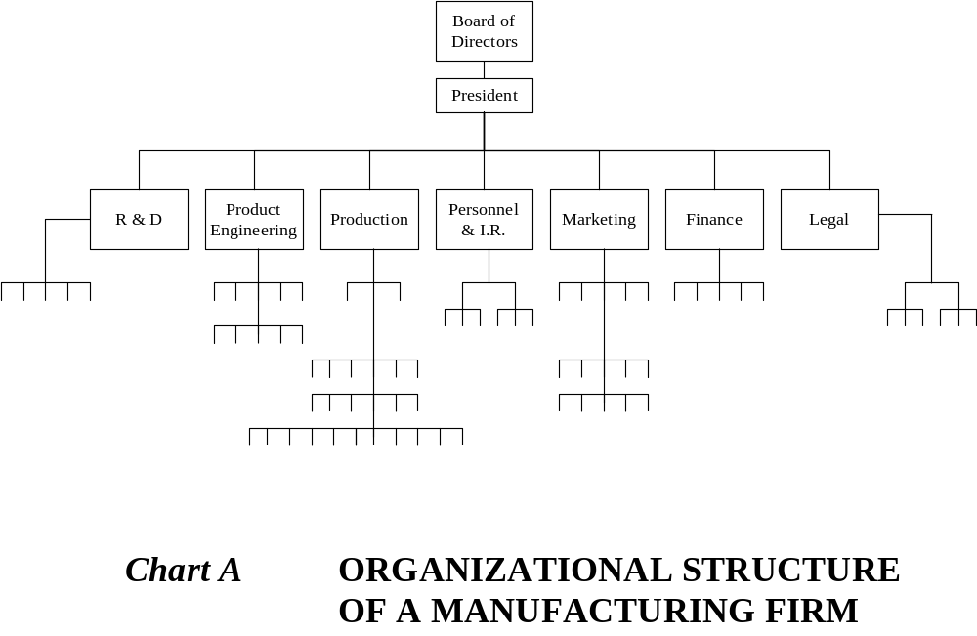

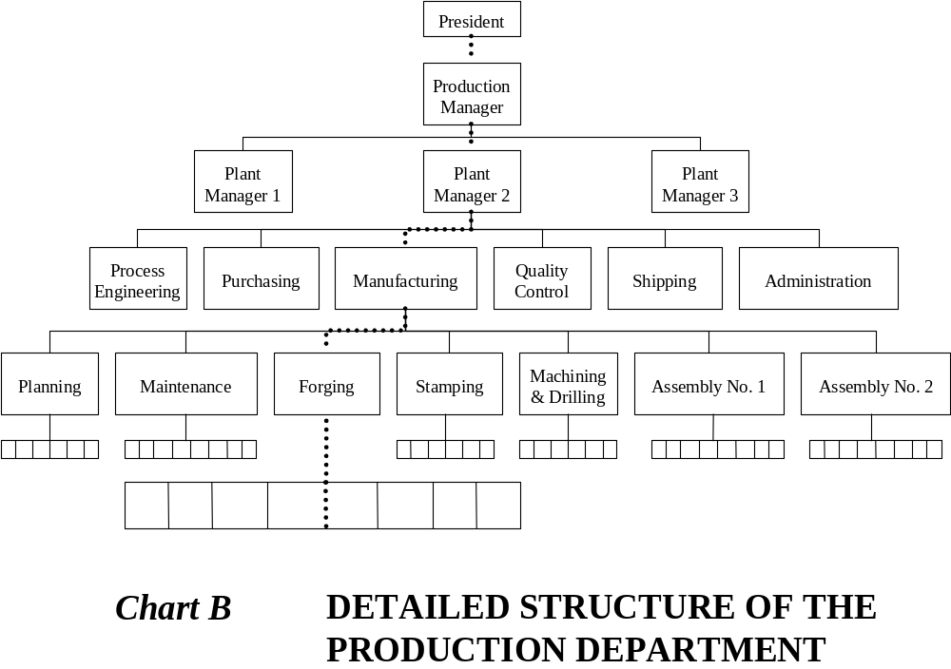

Chart A illustrates an organization divided on the principle of functional specialization. Each functional department has its own hierarchical mode of organization. Chart B illustrates details relating to the production department. Note the chain of command which runs from top to bottom of the organization. From any place at the bottom of the hierarchy there is only one route to the top, a reflection of the principle that each subordinate should have no more than one superior. An example is indicated by the highlighted line. Note the different "spans of control". The chief executive in Chart A has a span of control equal to seven. The foreman of the forging section in the production department (Charts A and B) has a span of control of twelve. The production manager has a span of three. Note how the advisory or "staff" departments (e.g., finance, personnel, legal, R & D) have no direct authority over "line" departments such as the production department.

Exhibit 2.3. Organization chart illustrating the principles of classical management theory and bureaucratic organization

The ability to achieve this kind of decentralization has been greatly advanced during the course of the twentieth century through the development of management techniques like MBO and PPBS and the design of sophisticated management information systems (MIS), which are often used to establish the kinds of "top-down" control advocated by the classical theorists. For example, MBO is now often used to impose a mechanistic system of goals and objectives on an organization. These are then used to control the direction in which managers and employees can take the organization, e.g., through the development of performance targets consistent with these goals. The same often happens with PPBS and other budgeting systems, with MIS being used to provide the detailed information necessary to implement the controls on a monthly, weekly, and even daily basis.
In this way the ideas of the classical management theorists are reinforced under the guise of modern management. This often occurs because the people designing these management systems have come to think about organization mechanistically and are unaware of other ways in which these techniques could be used-for example, to promote the kind of organizational learning and inquiry discussed in Chapter 4, or the participative corporate cultures or systems of organizational democracy discussed in Chapters 5 and 6.
The whole thrust of classical management theory and its modern application is to suggest that organizations can or should be rational systems that operate in as efficient a manner as possible. While many will endorse this as an ideal, it's easier said than done, because we are dealing with people, not inanimate cogs and wheels. In this regard it is significant that the classical theorists gave relatively little attention to the human aspects of organization. While they frequently recognized the need for leadership, initiative, benevolence, equity, esprit de corps, and other factors that might influence human motivation, organization as such was mainly understood as a technical problem. The classical theorists recognized that it was important to achieve a balance or harmony between the human and technical aspects of organization, especially through appropriate selection and training procedures, but their main orientation was to make humans fit the requirements of mechanical organization. And as we will see, for this they have been much criticized.

SCIENTIFIC MANAGEMENT

In Frederick the Great's approach to military organization we thus find many of the basic principles later elaborated by the classical management theorists. We also find many of the principles elaborated by the other great Frederick of organization theory, Frederick Taylor, who pioneered what is now known as scientific management.
Taylor was an American engineer and a flamboyant if somewhat disturbed personality. By his death in 1915 he had gained a reputation as a major "enemy of the working man" having been summoned in 1911 to defend his system of management before a committee of the U. S. House of Representatives. While one of the most maligned and criticized of all organization theorists, he has also proved to be one of the most influential. His principles of scientific management provided the cornerstone for work design throughout the first half of this century, and in many situations prevail right up to the present day.
Taylor advocated five simple principles, which can be summarized as follows:

- Shift all responsibility for the organization of work from the worker to the manager; managers should do all the thinking relating to the planning and design of work, leaving the workers with the task of implementation.
- Use scientific methods to determine the most efficient way of doing work; design the worker's task accordingly, specifying the precise way in which the work is to be done.
- Select the best person to perform the job thus designed.
- Train the worker to do the work efficiently.
- Monitor worker performance to ensure that appropriate work procedures are followed and that appropriate results are achieved.

In applying these principles Taylor advocated the use of time-and-motion study as a means of analyzing and standardizing work activities. His scientific approach called for detailed observation and measurement of even the most routine work, to find the optimum mode of performance. Under Taylor's system menial tasks such as pig-iron handling and earth shoveling became the subjects of science. He fused the perspective of an engineer with an obsession for control.
Prominent models of his approach to scientific management are found in numerous manufacturing firms, retail organizations, and offices. Consider, for example, the fast-food chains serving hamburgers, pizzas, and other highly standardized products. Here work is often organized in the minutest detail on the basis of designs that analyze the total process of production, find the most efficient procedures, and then allocate these as specialized duties to people trained to perform them in a very precise way. All the "thinking" is done by the managers and designers, leaving all the "doing" to the employees. The management observation checklist presented in Exhibit 2.1 provides the perfect illustration of Taylor's approach to management, showing how a simple job such as taking and serving a customer's order can be split into many separate elements which can each be observed and evaluated. Taylor would have been well pleased with such a system of work evaluation.
The same approach to work design is also found in assembly-line manufacture. Here Taylor's ideas are built into the technology itself, making the workers servants or adjuncts to machines that are in complete control of the organization and pace of work.
We also see Taylor's methods influencing the organization of office work through "organization and methods" and "work study" projects. These projects break integrated tasks into specialized components that can then be allocated to different employees. Thus in processing an insurance claim form, one employee may be responsible for checking the claim against the policy, another may initiate an evaluation process, another may conduct the evaluation, yet another may evaluate the evaluation, and so on. Systematically applied, Taylor's five principles lead to the development of "office factories" where people perform fragmented and highly specialized duties in accordance with an elaborate system of work design and performance evaluation.
The effect of Taylor's scientific management on the workplace has been enormous, increasing productivity manyfold while accelerating the replacement of skilled craftspeople by unskilled workers. And it is for these reasons that it has been so influential yet so maligned. For the increases in productivity have often been achieved at great human cost, reducing many workers to automatons, just as the army reforms of Frederick the Great did to his soldiers over 150 years earlier.
The human problems resulting from such methods of production have been glaringly obvious ever since they were first introduced, especially when built into assembly-line technology. For example, when Henry Ford established his first assembly line to produce the Model T, employee turnover rose to approximately 380 percent per annum. Only by doubling wages to his famous "$5 a day" was he able to stabilize the work situation and persuade workers to accept the new technology. In periods of high employment when jobs are plentiful, workers still often shun the assembly line, as witnessed in the early 1970s when turnover in some plants, such as Ford's at Wixom, was running at almost 100 percent p.a. For most people assembly-line work is simply boring or alienating. Job cycles are often very short, with workers sometimes being asked to complete work involving seven or eight separate operations every forty or fifty seconds, seven or eight hours a day, fifty weeks a year. When General Motors decided to tighten up on efficiency in its Lordstown plant in the late 1960s, the speed of the assembly line was raised to increase output from 60 to 100 cars per hour. At this new pace each worker had thirty-six seconds to perform at least eight different operations, such as walking, lifting, handling, raising a carpet, bending to fasten bolts, fastening them by air gun, replacing the carpet, and putting a sticker on the hood.
The principle of separating the planning and design of work from its execution is often seen as the most pernicious and far-reaching element of Taylor's approach to management, for it effectively "splits" the worker, advocating the separation of hand and brain. As Taylor was fond of telling his workers, "You are not supposed to think. There are other people paid for thinking around here". Men were no more than "hands" or "'manpower," the energy or force required to propel the organizational machine. The jobs they were required to perform were simplified to the ultimate degree so that workers would be cheap, easy to train, easy to supervise, and easy to replace. Just as the system of mass production required that products be assembled from interchangeable parts, Taylor's system rationalized the workplace so that it could be "manned" by interchangeable workers.
Over the years Taylor's approach to management has been extended and refined in many ways. For example, his contemporaries Frank and Lillian Gilbreth carried out important studies of human motion in the performance of work. The essence of mechanization rests in reducing complex procedures to sets of separate motions, which can then be reproduced mechanically at will. The Gilbreths' focused on this aspect of work activity, designing jobs for maximum efficiency in the use of effort. Along with Taylor, they made important contributions to the principles employed in assembly-line production and to the science of ergonomics, which studies the use of energy in the workplace. Interestingly, Taylor's principles have crossed many ideological barriers, being extensively used in the USSR as well as in capitalist countries. This fact signifies that Taylorism is as much a tool for securing general control over the workplace as a means toward the generation of profit. Though the USSR is not averse to profitable use of productive resources, one of the great attractions of Taylorism rests in the power it confers to those in control.
While Taylor is often seen as the villain who created scientific management, it is important to realize that he was really part of a much broader social trend involving the mechanization of life generally. For example, the principles underlying Taylorism are now found on the football field and athletics track, in the gymnasium, and in the way we rationalize and routinize our personal lives. Taylor gave voice to a particular aspect of the trend towards mechanization, specialization, and bureaucratization that Max Weber saw as such a powerful social force. Taylorism was typically imposed on the work-force. But many of us impose forms of Taylorism on ourselves as we train and develop specialized capacities for thought and action and shape our bodies to conform with preconceived ideals. Under the influence of the same kind of mechanism that has helped make Taylorism so powerful, we often think about and treat ourselves as if we were machines.
The really distinctive feature of Taylorism thus is not the fact that Taylor tried to mechanize the organization of people and work, but the degree to which he was able to do this. For Taylor's workers were expected to be as reliable, predictable, and efficient as the robots that are now replacing them. History may well judge that Taylor came before his time. His principles of scientific management make superb sense for organizing production when robots rather than human beings are the main productive force, when organizations can truly become machines.

Strengths and limitations of the machine metaphor

"Set goals and objectives and go for them "
"Organize rationally, efficiently, and clearly."
"Specify every detail so that everyone will be sure of the jobs that they have to perform."
"Plan, organize, and control, control, control."

These and other similar ideas are often ingrained in our way of thinking about organization and in the way we read and evaluate organizational practice. For many people it is almost second nature to organize by setting up a structure of clearly defined activities linked by clear lines of command, communication, coordination, and control. Thus when a manager designs an organization he or she frequently designs a formal structure of jobs into which people can then be fitted. Or, if the people are available first, it is a question of finding everyone a clearly defined role to play. When a vacancy arises in an organization, managers frequently talk about having "a slot" to fill. Much of our training and education is often geared to making us "fit in" and feel comfortable in our appointed place, so that organization can proceed in a rational and efficient way.
Classical management theory and scientific management were each pioneered and sold to managers as the "one best way to organize". The early theorists believed that they had discovered the principles of organization, which, if followed, would more or less solve managerial problems forever. Now, we only have to look at the contemporary organizational scene to find that they were completely wrong on this score. And indeed, if we look closely, we find that their management principles often lie at the basis of many modern organizational problems.
Images or metaphors only create partial ways of seeing. For in encouraging us to see and understand the world from one perspective they discourage us from seeing it from others. This is exactly what has happened in the course of developing mechanistic approaches to organization. For in understanding organization as a rational, technical process, mechanical imagery tends to underplay the human aspects of organization, and to overlook the fact that the tasks facing organizations are often much more complex, uncertain, and difficult than those that can be performed by most machines.
The strengths and limitations of the machine as a I metaphor for organization are reflected in the strengths and limitations of mechanistic organization in practice.
The strengths can be stated very simply. For mechanistic approaches to organization work well only under conditions where machines work well: (a) when there is a straightforward task to perform; (b) when the environment is stable enough to ensure that the products produced will be appropriate ones; (c) when one wishes to produce exactly the same product time and again; (d) when precision is at a premium; and (e) when the human "machine" parts are compliant and behave as they have been designed to do.
Some organizations have had spectacular success using the mechanistic model, because these conditions are all fulfilled. Take for example the McDonald's hamburger chain, which has established a solid reputation for excellent performance in the fast-food industry. The firm has mechanized the organization of all its franchise outlets all over the world so that each can produce a uniform product. The firm serves a carefully targeted mass market in a perfectly regular and consistent way, with all the precision that "hamburger science" can provide. (The firm actually has its own "Hamburger U" for teaching this science to its managers, and has a detailed operating manual to guide franchises in the daily operations of the McDonald's system.) The firm is exemplary in its adoption of Tayloristic principles and recruits a nonunionized labor force, often made up of high school and college students, that will be happy to fit the organization as designed. And the "machine" works perfectly most of the time. Of course, the company also has a dynamic and innovative character, but this is for the most part confined to its central staff who do the thinking, i.e., the policy development and design work, for the corporation as a whole.
Many franchising systems have used the same Tayloristic approach with great effect, centralizing the design and development of products or services and decentralizing implementation in a highly controlled way. The use of scientific methods to determine the work to be performed, manuals that set standards and codify performance in minute detail, well-developed recruitment and training plans, and comprehensive systems of job evaluation often provide the recipe for success, provided that the service or product is amenable to definition and control in this way.
Surgical wards, aircraft maintenance departments, finance offices, courier firms, and other organizations where precision, safety, and clear accountability are at a premium are also often able to implement mechanistic approaches successfully, at least in certain aspects of their operations.
However, despite these successes, mechanistic approaches to organization often have severe limitations. In particular they: (a) can create organizational forms that have great difficulty in adapting to changing circumstances; (b) can result in mindless and unquestioning bureaucracy; (c) can have unanticipated and undesirable consequences as the interests of those working in the organization take precedence over the goals the organization was designed to achieve; and (d) can have dehumanizing effects upon employees, especially those at the lower levels of the organizational hierarchy.
Mechanistically structured organizations have great difficulty adapting to changing circumstances because they are designed to achieve predetermined goals; they are not designed for innovation. This should come as no surprise, for machines are usually single-purpose mechanisms designed to transform specific inputs into specific outputs and can engage in different activities only if they are explicitly modified or redesigned to do so.
Changing circumstances call for different kinds of action and response. Flexibility and capacities for creative action thus become more important than narrow efficiency. It becomes more important to do the right thing in a way that is timely and "good enough" than to do the wrong thing well, or the right thing too late. In these respects, mechanistic organization falls victim to the kind of "segmentalism" that Rosabeth Moss Kanter has shown plagues so many modern corporations. The compartmentalization created by mechanistic divisions between different hierarchic levels, functions, roles, and people tends to create barriers and stumbling blocks.
For example, when new problems arise they are often ignored because there are no ready-made responses. Or they are approached in a fragmented rather than a holistic way so that they can be tackled through existing organizational policies, procedures, and patterns of expertise. But standardized procedures and channels of communication are often unable to deal effectively with new circumstances, necessitating numerous ad hoc meetings and committees, which, because they have to be planned to fit rather than disrupt the normal mode of operation, are often too slow or too late for dealing with issues. Problems of inaction and lack of coordination thus become rife. In such circumstances the organization frequently becomes clogged with backlogs of work because normal routine has been disrupted, and complex issues float up the organizational hierarchy as members at each level find in turn that they are unable to solve them. On the way, information often gets distorted, as people hide errors and the true nature and magnitude of problems for fear of being held responsible for them. Those in command of the organization thus frequently find themselves facing issues that are inappropriately defined, and which they have no real idea of how to approach. They are often forced to delegate them to special task forces or teams of staff experts or consultants - who, since they are often remote from the concrete problems being experienced, further increase the delay and inadequacy of response. The difficulty of achieving effective responses to changing circumstances is often further aggravated by the high degree of specialization in different functional areas within the organization (e.g., production, marketing, finance, product engineering). Interdepartmental communications and coordination are often poor, and people often have a myopic view of what is occurring, there being no overall grasp of the situation facing the enterprise as a whole. As a result the actions encouraged by one element of the organization often entail negative consequences for others, so that one element ends up working against the interests of another.
These problems are often compounded by the fact that mechanistic definitions of job responsibilities encourage many organizational members to adopt mindless, unquestioning attitudes such as "it's not my job to worry about that" or "that's his responsibility, not mine" or "I'm here to do what I'm told" Though often seen as employee attitudes, they are actually inherent in the mechanistic approach to organization. Defining work responsibilities in a clear-cut manner has the advantage of letting everyone know what is expected of them. But it also lets them know what is not expected of them. Detailed job descriptions have this two-edged character, creating many problems when the organization faces changing circumstances that call for initiative and
flexibility in response.
This institutionalized passivity and dependency can even lead people to make and justify deliberate mistakes on the premise that they are obeying orders. The hierarchical organization of jobs builds on the idea that control must be exercised over the different parts of the organization (to ensure that they are doing what they are designed to do), rather than being built into the parts themselves. Supervisors and other hierarchical forms of control do not just monitor the performance of workers - they also remove responsibility from workers, because their function really becomes operational only when problems arise. In a similar way, a system of quality control on a production line often institutionalizes the production of defective goods. People realize that they are allowed a quota of errors, developing the attitude that "I won't bother to correct that one - I'll leave it for the inspectors".
Much of the apathy, carelessness, and lack of pride so often encountered in the modern workplace is thus not coincidental: it is fostered by the mechanistic approach to organization that dominates work life. The rationality underlying mechanistic design is what may be described as a "functional" or "instrumental" rationality. It derives from the way people and jobs fit together in a fixed design. This kind of rationality contrasts with the "substantial rationality" of systems where people are encouraged to determine whether what they are doing is appropriate and to adjust actions accordingly. Whereas under the bureaucratic ethos actions are rational because of their place within the whole, substantial rationality requires actions that are informed by intelligent awareness of the complete situation. Whereas bureaucratic rationality is mechanical, substantial rationality is reflective and self-organizing. Mechanistic organization discourages initiative, encouraging people to obey orders and keep their place rather than to take an interest in, challenge, and question what they are doing. People in a bureaucracy who question the wisdom of conventional practice are viewed more often than not as troublemakers. Therefore apathy often reigns, as people learn to feel powerless about problems which collectively they understand and ultimately have the power to solve.
These difficulties are often linked to another set of problems: the development of subgoals and sets of interests that undermine the organization's ability to meet its primary objectives. The functional specialization in which elements of the organizations overall mission are broken down and made the responsibility of separate people or departments creates a structure that is supposed to be a system of cooperation but often turns out as a system of competition. The intention of mechanistic-bureaucratic organization is that the parts should contribute to the goals and objectives of the whole. But interpreted from a wider perspective the hierarchical structure is not just a network of jobs and roles, but also a career system in which individuals compete for limited places higher up the hierarchy. Competition also occurs because resources available to the organization are often limited, so that developments in one area (e.g., the marketing department) may exclude developments in others. As a consequence, the mechanistic organization can produce behavior which, while rational for the individuals involved in specific activities (e.g., the development of the marketing function), may prove irrational for the whole. Empire building, careerism, the defense of departmental interests and pet projects, and the padding of budgets to create slack resources may subvert the working of the whole. If the organization is staffed by rational men and women who behave in accordance with the formal interests and aims of the total organization, "fitting in" rather than using the organization for other purposes, then this may not occur. But humans are human, and the best-laid plans have a habit of turning in ways never intended by their creators. Formal organizations thus often become guided toward the achievement of informal ends, some of which may be quite contrary to the aims underlying the original design.
A final set of problems relate to human consequences. The mechanistic approach to organization tends to limit rather than mobilize the development of human capacities, molding human beings to fit the requirements of mechanical organization rather than building the organization around their strengths and potentials. Both employees and organizations lose from this arrangement. Employees lose opportunities for personal growth, often spending many hours a day on work they neither value nor enjoy, while organizations lose the creative and intelligent contributions that most employees are capable of making, given the right opportunities.
Mechanistic approaches to organization have proved incredibly popular, partly because of their efficiency in the performance of certain tasks, but also because of their ability to reinforce and sustain particular patterns of power and control. The machine metaphor has special appeal for individuals and groups who wish to exercise a close control over people and their activities; and as we will see in Chapters 6, 7, and 9, its popularity and use are often supported by a complex set of factors. However, there can be little doubt that the increasing rate of societal flux and change poses many problems for organizations based on mechanical designs. Mechanistic organizations may well in the end prove to be but one specific kind of organization, generated by, yet only imperfectly suited to, the requirements of the mechanical age. Now that we are entering an age with a completely new technological base drawing on microelectronics, new organizational principles are likely to become of increasing importance. The images of organization considered in the following chapters give a glimpse of what may be both possible and appropriate for managing these new times.

